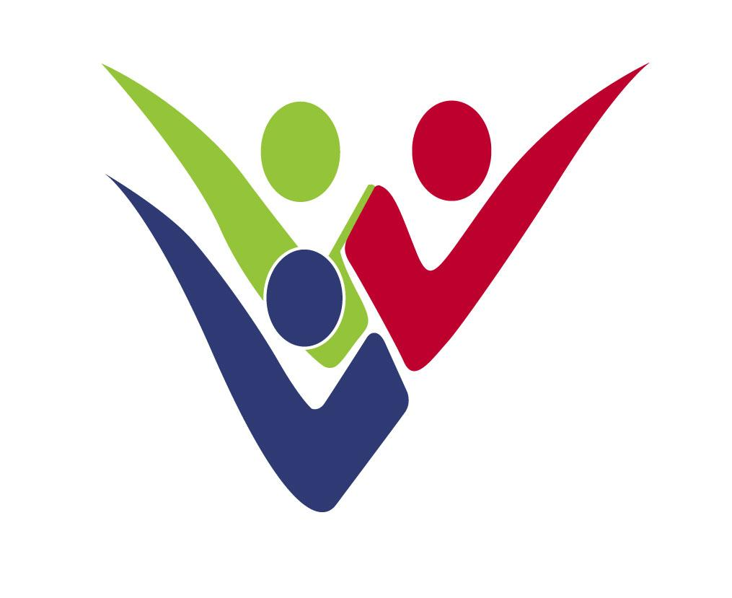
DEPARTMENT FOR SOCIAL INCLUSION OF PERSONS WITH DISABILITIES
1430 NICOSIA

REPUBLIC OF CYPRUS

DEPUTY MINISTRY OF
SOCIAL WELFARE

ANNUAL REPORT 2023
DEPARTMENT FOR SOCIAL INCLUSION OF PERSONS WITH DISABILITIES

The Department for Social Inclusion of Persons with Disabilities (DSID) has been established as from 1/1/2009, as a new Department of the Ministry of Labour, Welfare and Social Insurance, according to Decision of the Council of Ministers no. 66.763 dated 6/2/2008 and the State Budget Law for 2009. From 1/1/2023 the DSID’s responsibities have been moved under the Deputy Minisrty of Social Welfare.

The aim of the Department is the promotion of social protection, social inclusion and employment of persons with disabilities. The vision of the Department is the improvement of quality of life of persons with disabilities and the creation of new prospects for social inclusion through the formulation, coordination and implementation of reforms.

The organisational structure of the Department is based on four sectors: a) Management of projecs funded by the EU being the System for the Assessment of Disability, the Supported Living Homes and the Centre for Family Intervention and Support for Autism, b) Social Benefits, c) Vocational Rehabilitation and other support services and d) Focal Point for the implementation of the UN Convention for the Rights of Persons with Disabilities. In addition the Department chairs the Special Fund of the Vocational Training and Rehabilitation Centre, the Executive Board of the Christos Stelios Ioannou Foundation and the Committee for the Protection of Persons with Intellectual Disability.

1. Management of the System for the Assessment of Disability Project

The project “Expansion and Upgrading of the Implementation of the New System for the Assessment of Disability” is implemented by DSID in the programming period 2021-2027. The project concerns an expansion of the previous project implemented in the period 2007-2013 for the introduction of the new disability assessment system as well as the expansion and upgrading of the system during the period 2014-2020. As from December 2013 the first Disability Assessment Center operates in Nicosia, in May 2017 the second Center operated in Limassol and in October 2021 the third Center operated in Larnaca.
Through the new system the disability and the needs of the applicant are assessed and certified by multidisciplinary committees and the citizen receives a holistic report on the rights for social benefits and services that is entitled to. The assessment results are input in the national disability data base that is gradually created aiming to support the formulation of targeted policies of the state relating to disability. In 2023 4899 assessments were performed. From 2013 until the end of 2023, assessments were performed for 25.523 persons with disabilities.
2. Supported Living Homes Project

During 2023, the operation of 9 supported living residences were continued. In addition, during 2023, a further supported living home was operating to service three individuals with autism and additionally four individual independent living support services programs. In 2023, the residences served 54 people with disabilities, 36 men and 18 women. People with disabilities enjoy in these small family-type homes a safe, dignified and quality living with the necessary support services in the fields of care, communication, entertainment, skills development, socialization.

3. Center for Family Intervention and Support for Autism

In October 2021 the new Center for Family Intervention and Support for Autism started its operation after the signing of a public contract with the Joint Venture of the European University of Cyprus, the Social Element-Centre for Social and Human Development Ltd and the Codeca- Center for Social Cohesion Development and Care Ltd. The creation and operation of the Center aims at the timely provision of intervention and support services, so that children with autism participate in all aspects of social life. At the same time, the aim of the project is to maintain family cohesion, a necessary element both for the wider social cohesion and prosperity but also for the progress of the children themselves. The mission of the Center is to provide specialized services to children up to the age of compulsory education, who have been diagnosed with autism, as well as to their families, such as: (a) Psychological Support, Counseling and Psychoeducation Service, (b) Home Training and Support Service for the child and the family in the context of early childhood intervention specifically focused on children with Autism Spectrum Disorders, (c) Social Support Service. The Center will be able to serve and provide its services to about 300 children and their families annually across Cyprus. The funding of the project continues in the new programming period 2021-2027.

4. Social Benefit Schemes for Persons with Disabilities

The main Social Benefit Schemes of the Department are the following:
- Severe motor disability allowance: Persons with severe motor disabilities are entitled a monthly allowance of €386 (At 31/12/2023, 2404 persons were entitled to this allowance and the cost for 2023 was €11.329.440)
- Care allowance for persons with paraplegia or tetraplegia of €400 or €500 monthly for persons with paraplegia and €900 or €1100 monthly for persons with tetraplegia (At 31/12/2023: 1335 beneficiaries with paraplegia with a cost at €7.232.278 and 951 beneficiaries with tetraplegia with a cost at €11.228.221)
- Special Allowance for Blind Persons of €361,65 monthly (At 31/12/2023: 1997 beneficiaries with a cost for 2023 at €9.022.806)
- Mobility Allowance of €75- €150 monthly (At 31/12/2023: 4196 beneficiaries with a cost for 2023 at €5.452.143)
- Financial Assistance for persons with disabilities in order to buy a car (In 2023: 308 beneficiaries with a cost for 2023 at €1.309.500)
- Financial assistance for the provision of technical aid (In 2023: 1200 beneficiaries with a cost for 2023 at €1.621.036)
- Financial assistance for the provision of wheel chairs (In 2023: 478 beneficiaries with a cost for 2023 at €1.616.620).
- Financial Assistance for vacation (At 31/12/2023: 660 beneficiaries with a total cost of €315.333)
- The scheme for providing the Blue Badge i.e. the card for facilitating parking for persons with disabilities continued to operate.
- The scheme for providing the European Disability Card, based on a European project with the participation of 8 EU member states. The special website for the Card is www.eudisabilitycard.gov.cy (for 2023: 1303 new beneficiaries of the Card)

5. Vocational Rehabilitation and other Support Services

The main Vocational Rehabilitation Programmes and Schemes provided by the Department are the following:

- The Department is responsible to support and monitor the implementation of the Recruitment of Persons with Disabilities in the Wider Public Sector Law which is a special law forcing all public services to recruit up to a quota of 10% of their vacant posts, persons with disabilities who fulfill specific objective criteria. The Department supports the authorities responsible for the recruitments by providing them independent reports by multidisciplinary committees assessing disability and capability for the duties of the specific posts. 313 persons with disabilities were recruited under the Law since 2010.
- Scheme for the creation and operation of small units for self-employment purposes of Persons with Disabilities. The Scheme provides a grant up to €8.543 to persons with disabilities who do not have the financial means for self-employment through the Special Fund of the Vocational Rehabilitation Centre for Persons with Disabilities. In 2023, 3 applications were approved of a total budget of €17.500.
- The Supported Employment Scheme, which funds Organisations for persons with disabilities with an amount of up to €13.500 yearly for each supported employment program, which intends to help groups of 5-10 persons with disabilities (mainly intellectual disability) to get and maintain a job position in the open labour market, by a special job coach. In 2023, 27 programs operated which benefited 400 persons with disabilities, with a total cost of €310.683.
- The Vocational Training Scheme which funds persons with disabilities with an amount of up to €1.708,60 in order to get training courses of their own choice, which they will increase their employment opportunities . In 2023, 8 applications were approved and the total cost was €6.450.

Other Support Services are:
- Schemes for the subsidization of Organizations to implement Vocational Training Programmes for Persons with Disabilities as well as Disability Professionals. No applications were submitted in 2023
- Financial assistance to the organisations of persons with disabilities for coverage the expenses of the operation of social programs (14 organisations were subsidized with a cost in 2023 of €109.813. The Confederation of the Organisations of Disabled People also receives an annual grant for almost all its expenses (€100.000 for 2023 and €50.000 for the operation of a pilot project).
- Subsidisation of organisations of persons with severe disabilities to recruit and manage Social Assistants for their members in order to support them at visiting state services, hospitals and doctors, banks, day care programmes, shopping, recreation activities etc (9 organisations were subsidized for 900 beneficiaries with disabilities and a cost for 2023 of €192.528).
- Presidency of Executive Board of the Christos Stelios Ioannou Foundation by the Director of the Department who represents at the Board the Director General of the Deputy Ministry of Social Welfare.
Moreover, important tools were delivered to the Department in September 2023, such as training programs in fifteen sustainable occupations, a training program in entrepreneurship and social enterprises, a training program for vocational rehabilitation counselors and a plan for the provision of counseling services. The development of an action plan to encourage and support people with disabilities to establish their own social enterprises or join them as employees has started.

6. Focal Point for the implementation of the UN Convention for the Rights of Persons with Disabilities

The monitoring and promotion of the implementation of the UN Convention for the Rights of Persons with Disabilities is coordinated by the Department for Social Inclusion of People with Disabilities which has been appointed by the Council of Ministers as the Focal Point in Cyprus. This is a collective effort in cooperation with all public services co responsible for disability issues, the Office of the Ombudsman and Human Rights Commissioner who has been defined as the Independent Mechanism for the Convention as well as the Pancyprian Confederation of the Organisations of the Disabled who have the right to participate in all mechanisms for the monitoring and implementation of the Convention.

The Department for Social Inclusion of Persons with Disabilities coordinated in cooperation with the state services responsible for disability issues, the preparation of the First National Strategy for Disability 2018-2028 and the three National Disability Action Plans (2013-2015, 2018- 2020 and 2021-2023), with the aim of defining the vision, values, strategic aspirations and goals of the Republic of Cyprus for the implementation of additional actions that further ensure the rights of citizens with disabilities, in all areas of their life.

The First National Disability Strategy 2018-2028 defines the vision, values, strategic goals and objectives of the Republic of Cyprus for the implementation of the rights of persons with disabilities, by directing all the state actors towards those actions that will add value and will further improve the quality of persons with disabilities’ life.

The National Disability Action Plan 2021-2023 which was approved by the Council of Ministers on 26/2/2022 contained 135 actions to be implemented by 8 Ministries and 3 Deputy Ministries, with the aim to promote:
- independent living, social inclusion, mobility and social protection of people with disabilities
- their employment and vocational training,
- education,
- the accessibility of persons with disabilities to the natural and built environment, transport and information,
- provision of health and rehabilitation services,
- information and awareness raising on disability issues.
In cooperation with the state services, the Department coordinated and prepared the report on the implementation of the actions of the third National Action Plan during the three years 2021-2023, with which the Pan-Cypriot Coordinating Council for Persons with Disabilities was informed in its session on 11/12/23. The general report for the three years 2021-2023 results in:
• 74 actions fully implemented, or 55%
• 49 partially implemented actions, or 36%
• 12 actions that were not implemented or a percentage of 9%, for various reasons (e.g. pandemic, understaffing of services, restructuring of action content.

In December 2023, the consultation began on the formulation of the Revised National Disability Strategy and the Fourth National Disability Action Plan 2024-2028

The Department also undertook the coordination of the co-competent Services for the drafting of the harmonization bill of the Directive (EU) 2019/882 of the European Parliament and of the Council of 17 April 2019 on the accessibility requirements for products and services. Τhe bill was prepared by the Department, was completed by the Deputy Ministry of Social Welfare, was approved by the Council of Ministers on 15.11.23 and was submitted to the Parliament on 30.11.2023.

